**//C program to generate square wave using DAC**

#include <stdio.h>

#include "lpc17xx.h"

void delay(uint32_t);

int main (void)

{

LPC_PINCON->PINSEL1 |= (2<<20); // set p0.26 to DAC output

while(1)

{

LPC_DAC->DACR = (0<<6)|(1<<16); //value to be converted with bias

delay(100000);

LPC_DAC->DACR = (1023<<6)|(1<<16); //value to be converted with bias

delay(100000);

}

}

void delay(uint32_t i)

{

uint32_t x;

for(x=0;x<=i;x++);

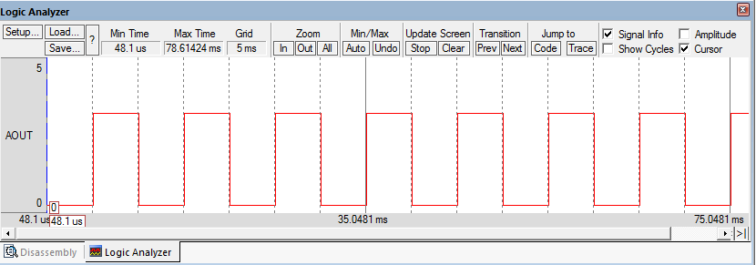 }

**//C program to generate +ve ramp using DAC**

#include <stdio.h>

#include "lpc17xx.h"

#define voltage 1024

uint32_t x;

int main (void)

{

LPC_PINCON->PINSEL1 |= (2<<20); // set p0.26 to DAC output

while(1)

{

for(x=0;x<=voltage;x++)

{

LPC_DAC->DACR = (x<<6)|(1<<16);

}

} }

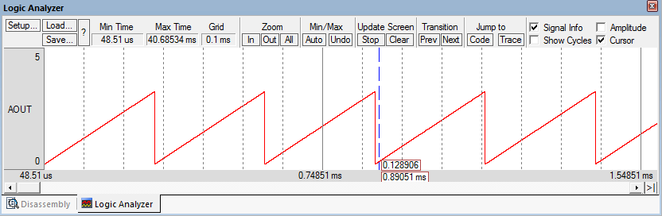

**//C program to generate -ve ramp using DAC**

#include <stdio.h>

#include "lpc17xx.h"

#define voltage 1024

uint32_t x;

int main (void)

{

LPC_PINCON->PINSEL1 |= (2<<20); // set p0.26 to DAC output

while(1)

{

for(x=voltage;x>=0;x--)

{

LPC_DAC->DACR = (x<<6)|(1<<16);

}

} }

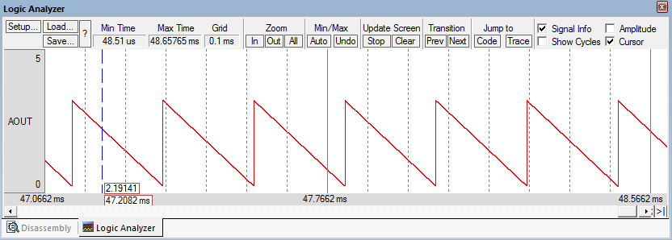

**//C program to generate sawtooth waveform using DAC**

#include <stdio.h>

#include "lpc17xx.h"

#define voltage 1024

uint32_t x;

void delay(uint32_t);

int main (void)

{

LPC_PINCON->PINSEL1 |= (2<<20); // set p0.26 to DAC output

while(1)

{

for(x=0;x<=voltage;x++)

{

LPC_DAC->DACR = (x<<6)|(1<<16);

}

delay(10000);

} }

void delay(uint32_t i)

{

uint32_t a;

for(a=0;a<=i;a++);

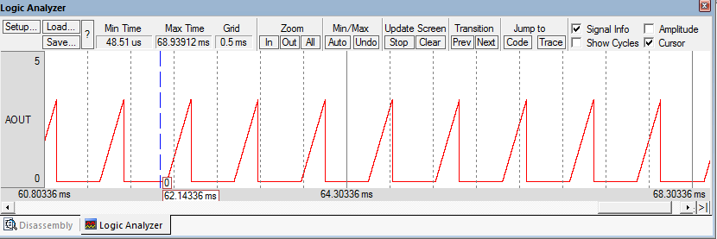 }

**//C program to generate Triangular waveform using DAC**

#include <stdio.h>

#include "lpc17xx.h"

#define voltage 1023

uint32_t x,y;

int main (void)

{

LPC_PINCON->PINSEL1 |= (2<<20); // set p0.26 to DAC output

while(1)

{

for(x=0;x<voltage;x++)

{

LPC_DAC->DACR = (x<<6)|(1<<16);

}

for(y=voltage;y>0;y--)

{

LPC_DAC->DACR = (y<<6)|(1<<16);

}

} }

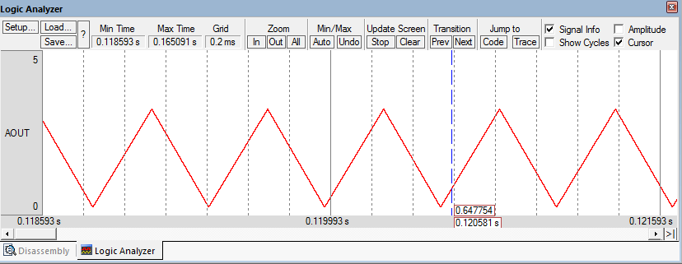

**//C program to generate Triangular waveform with delay using DAC**

#include <stdio.h>

#include "lpc17xx.h"

#define voltage 1023

uint32_t x,y;

void delay(uint32_t);

int main (void)

{

LPC_PINCON->PINSEL1 |= (2<<20); // set p0.26 to DAC output

while(1)

{

for(x=0;x<voltage;x++)

{

LPC_DAC->DACR = (x<<6)|(1<<16);

}

for(y=voltage;y>0;y--)

{

LPC_DAC->DACR = (y<<6)|(1<<16);

}

delay(10000);

} }

void delay(uint32_t i)

{

uint32_t a;

for(a=0;a<=i;a++);

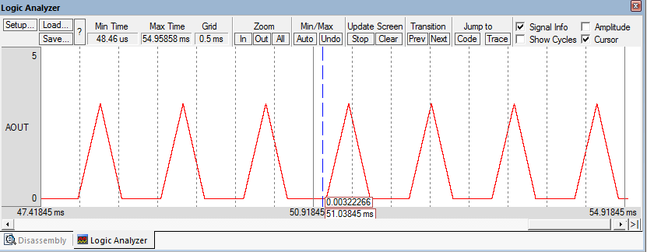 }

**//C program to generate combined triangular and square wave using DAC**

#include <stdio.h>

#include "lpc17xx.h"

#define voltage 1023

uint32_t x,y;

void delay(uint32_t);

int main (void)

{

LPC_PINCON->PINSEL1 |= (2<<20); // set p0.26 to DAC output

while(1)

{

for(x=0;x<voltage;x++)

{

LPC_DAC->DACR = (x<<6)|(1<<16);

}

for(y=voltage;y>0;y--)

{

LPC_DAC->DACR = (y<<6)|(1<<16);

}

LPC_DAC->DACR = (0<<6)|(1<<16);

delay(10000);

LPC_DAC->DACR = (voltage<<6)|(1<<16);

delay(10000);

LPC_DAC->DACR = (0<<6)|(1<<16);

delay(10000);

} }

void delay(uint32_t i)

{

uint32_t a;

for(a=0;a<=i;a++);

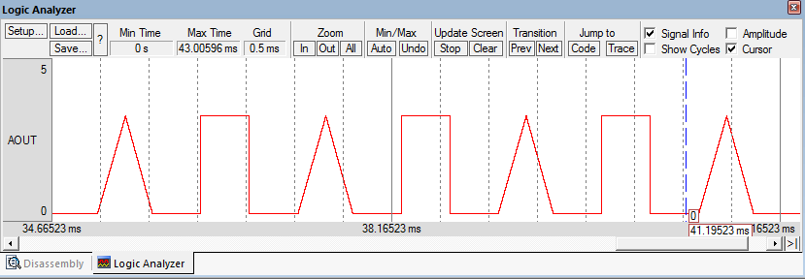 }

**//C program to generate +ve staircase waveform using DAC**

#include <stdio.h>

#include "lpc17xx.h"

#define voltage 1023

uint32_t x;

void delay(uint32_t);

int main (void)

{

LPC_PINCON->PINSEL1 |= (2<<20); // set p0.26 to DAC output

while(1)

{

for(x=0;x<=voltage;x=x+205)

{

LPC_DAC->DACR = (x<<6)|(1<<16);

delay(10000);

}

} }

void delay(uint32_t i)

{

uint32_t a;

for(a=0;a<=i;a++);

}

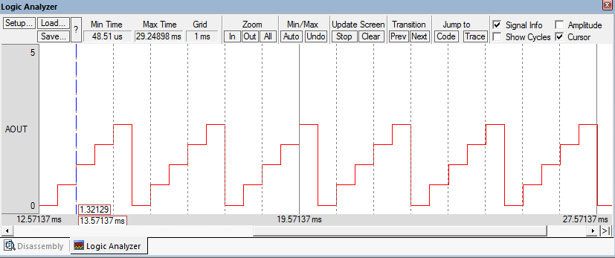

**//C program to generate -ve staircase waveform using DAC**

#include <stdio.h>

#include "lpc17xx.h"

#define voltage 1023

uint32_t x;

void delay(uint32_t);

int main (void)

{

LPC_PINCON->PINSEL1 |= (2<<20); // set p0.26 to DAC output

while(1)

{

for(x=voltage;x>=0;x=x-205)

{

LPC_DAC->DACR = (x<<6)|(1<<16);

delay(10000);

}

} }

void delay(uint32_t i)

{

uint32_t a;

for(a=0;a<=i;a++);

}

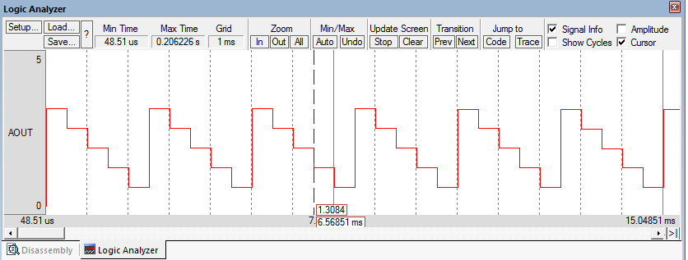

**//C program to generate staircase waveform using DAC**

#include <stdio.h>

#include "lpc17xx.h"

void delay(uint32_t);

int main (void)

{

LPC_PINCON->PINSEL1 |= (2<<20); // set p0.26 to DAC output

while(1)

{

LPC_DAC->DACR = (0<<6)|(1<<16);

delay(10000);

LPC_DAC->DACR = (205<<6)|(1<<16);

delay(10000);

LPC_DAC->DACR = (715<<6)|(1<<16);

delay(10000);

LPC_DAC->DACR = (205<<6)|(1<<16);

delay(10000);

LPC_DAC->DACR = (0<<6)|(1<<16);

delay(10000);

} }

void delay(uint32_t i)

{

uint32_t a;

for(a=0;a<=i;a++);

}

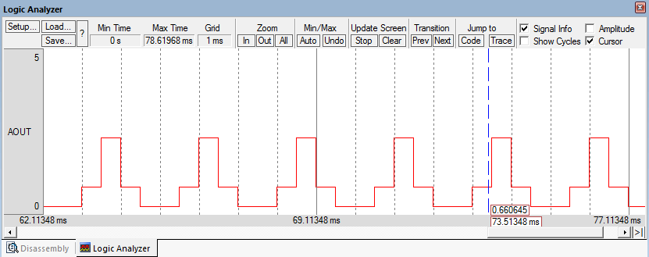

**//C program to generate sine wave using DAC**

#include <stdio.h>

#include "lpc17xx.h"

uint32_t x;

uint32_t sinetable[]={512,528,544,560,576,592,608,624,639,655,

670,685,700,715,730,744,759,773,786,800,813,826,838,850,862,

874,885,896,906,916,926,935,944,953,961,968,975,982,988,994,

999,1004,1008,1012,1015,1018,1020,1022,1022,1023,1023,1023,

1022,1022,1020,1018,1015,1012,1008,1004,999,994,988,982,975,

968,961,953,945,936,927,917,907,896,886,874,863,851,839,826,

813,800,787,773,759,745,731,716,701,686,671,656,640,624,609,

593,577,561,545,529,513,497,481,465,449,433,417,401,386,370,

355,339,324,310,295,280,266,252,238,225,212,199,186,174,162,

151,139,129,118,108,98,89,80,72,64,56,49,43,36,31,25,21,16,

13,9,6,4,2,1,0,0,0,1,2,4,6,9,12,16,20,25,30,35,42,48,55,63,

71,79,88,97,107,117,127,138,149,160,172,185,197,210,223,236,

250,264,278,293,307,322,337,352,368,383,399,415,430,446,462,

478,494};

int main (void)

{

LPC_PINCON->PINSEL1 |= (2<<20); // set p0.26 to DAC output

while(1)

{

for(x=0;x<200;x++)

{

LPC_DAC->DACR = (sinetable[x]<<6)|(1<<16);

}

}}

**Logic:**

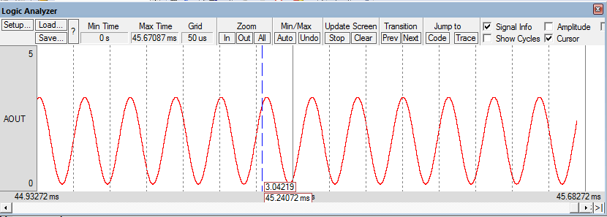**Vout = 512+512(sinΘ), where Θ =00 to 3600 at 1.80 interval, 200 values**

**//C program to generate pulse of different duty cycle using PWM**

#include<stdio.h>

#include <lpc17xx.h>

void PWM_init(void)

{

LPC_PINCON->PINSEL3 |= (2<<4)|(2<<8)|(2<<10);// pwm1.1 p1.18,pwm1.2 p1.20,pwm1.3 p1.21

LPC_PWM1->TCR=(1<<0);// enable counter and PWM

LPC_PWM1->PR=0;//to fix the period of pwm

LPC_PWM1->MCR=(1<<1);//reset the timer on match

LPC_PWM1->MR0=24999;//ton+toff = 1ms

LPC_PWM1->PCR=(1<<9)|(1<<10)|(1<<11);//PWM1,PWM2andPWM3 enable

}

int main (void)

{

PWM_init();

while(1)

{

LPC_PWM1->MR1=6250;//ton,duty cycle = 24999/6250=25%

LPC_PWM1->MR2=12500;//ton=12500,duty cycle = 24999/12500=50%

LPC_PWM1->MR3=18750;//ton=18750,duty cycle = 24999/18750=75%

LPC_PWM1->LER=0xe;//Enable the bits in LER register to load and latch the new

//match values in MR1,MR2 and MR3 registers

}

}

